Lab RDS

1. Search for RDS

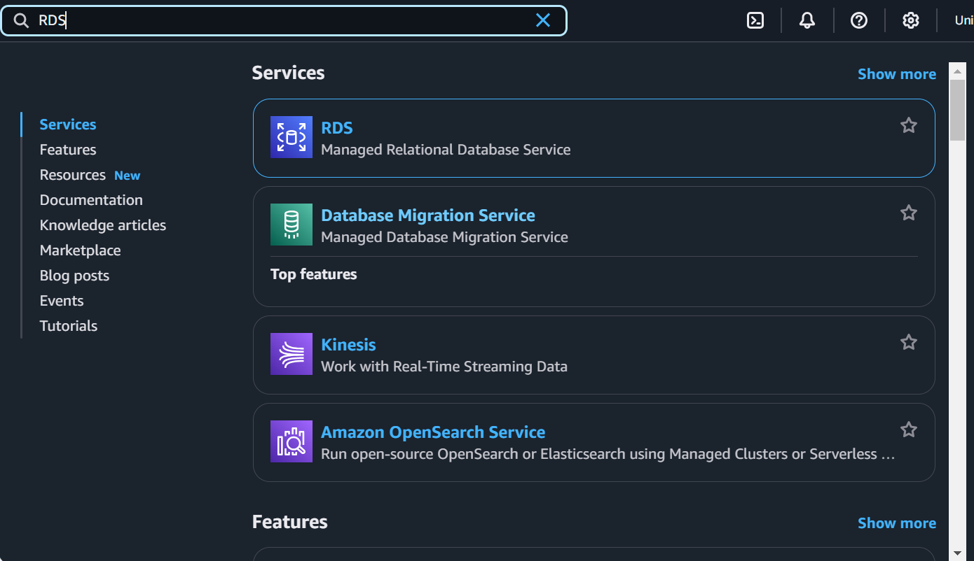

2)Click on Create Database

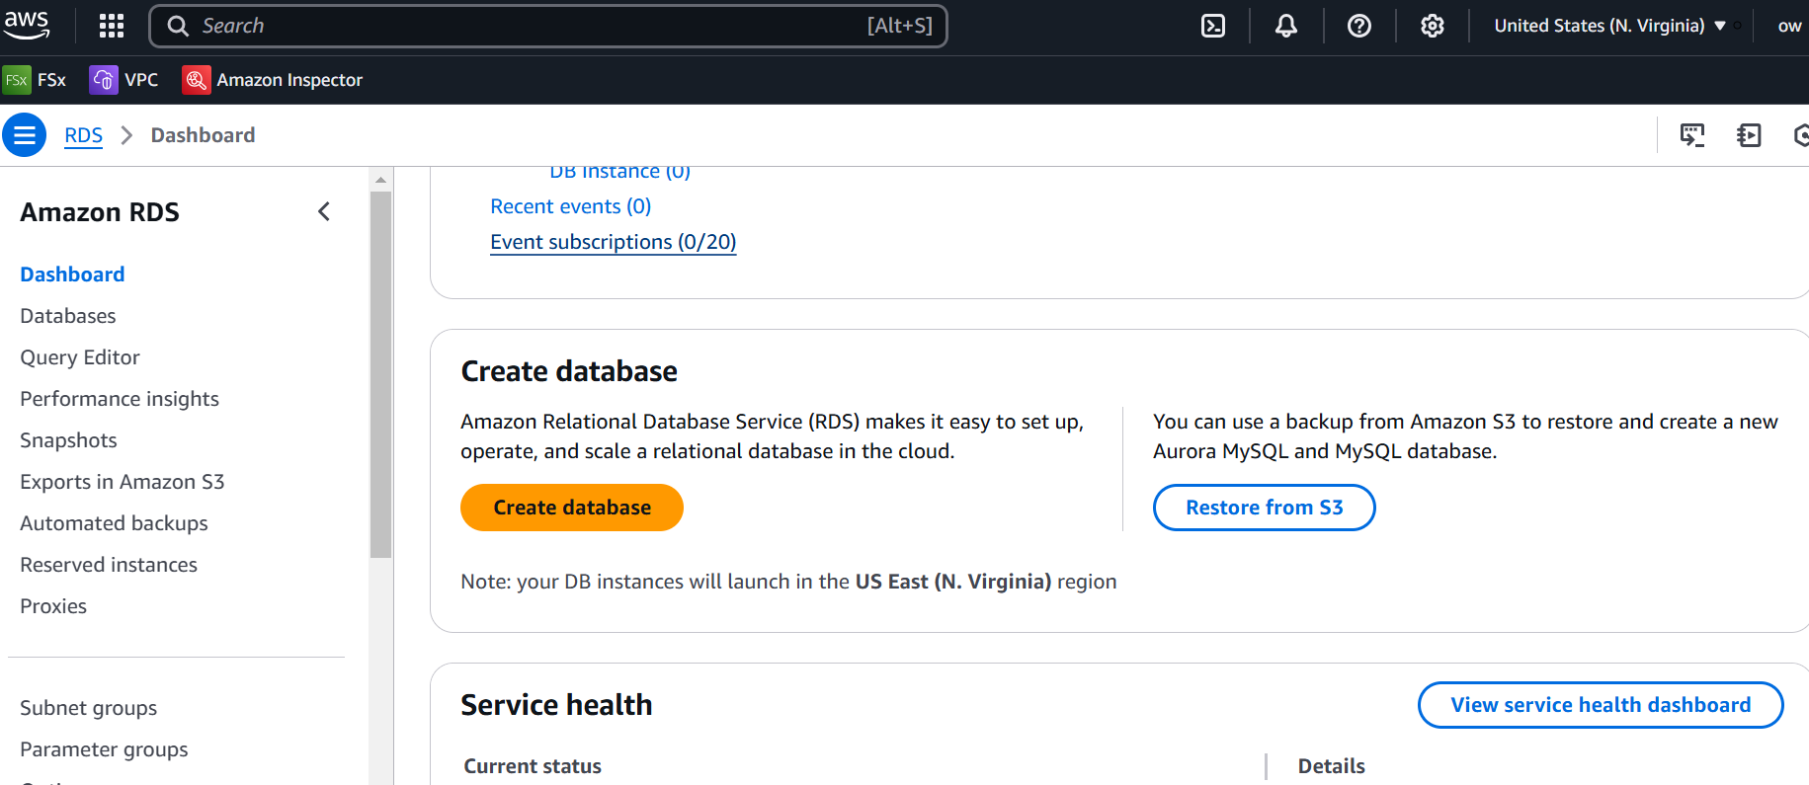

3) **Step 3: Choose a database creation method**

1. By default, “Standard Create” is selected. This method provides more control over the configuration of your database instance.
2. If you’re new to RDS, you can choose “Easy Create” for a simplified experience.

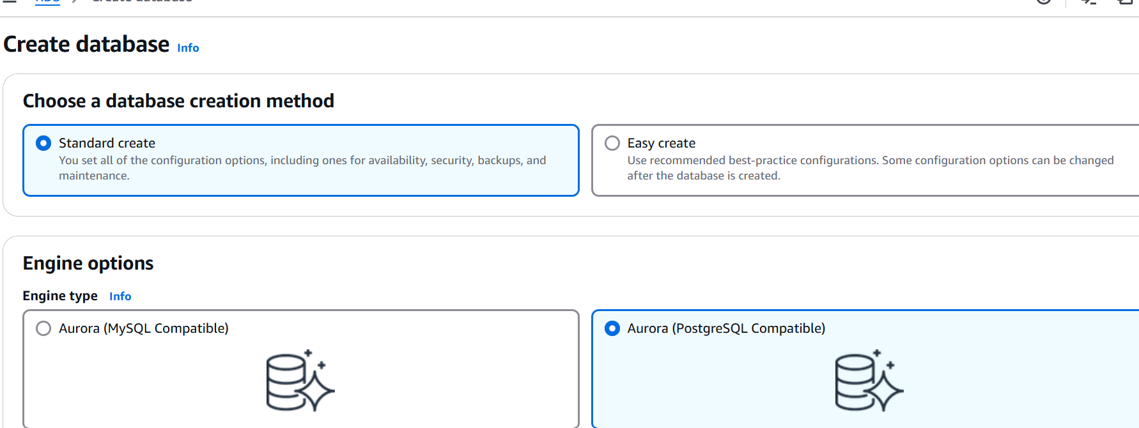

4)  **Select a database engine**

* Amazon Aurora: A high-performance, MySQL- and PostgreSQL-compatible relational database engine.
* MySQL: A popular open-source relational database engine.
* PostgreSQL: A powerful open-source object-relational database engine.
* MariaDB: A drop-in replacement for MySQL.
* Oracle Database: A popular enterprise-grade relational database engine.
* Microsoft SQL Server: A popular enterprise-grade relational database engine.
* IBM Db2: A powerful database engine suitable for demanding workloads.

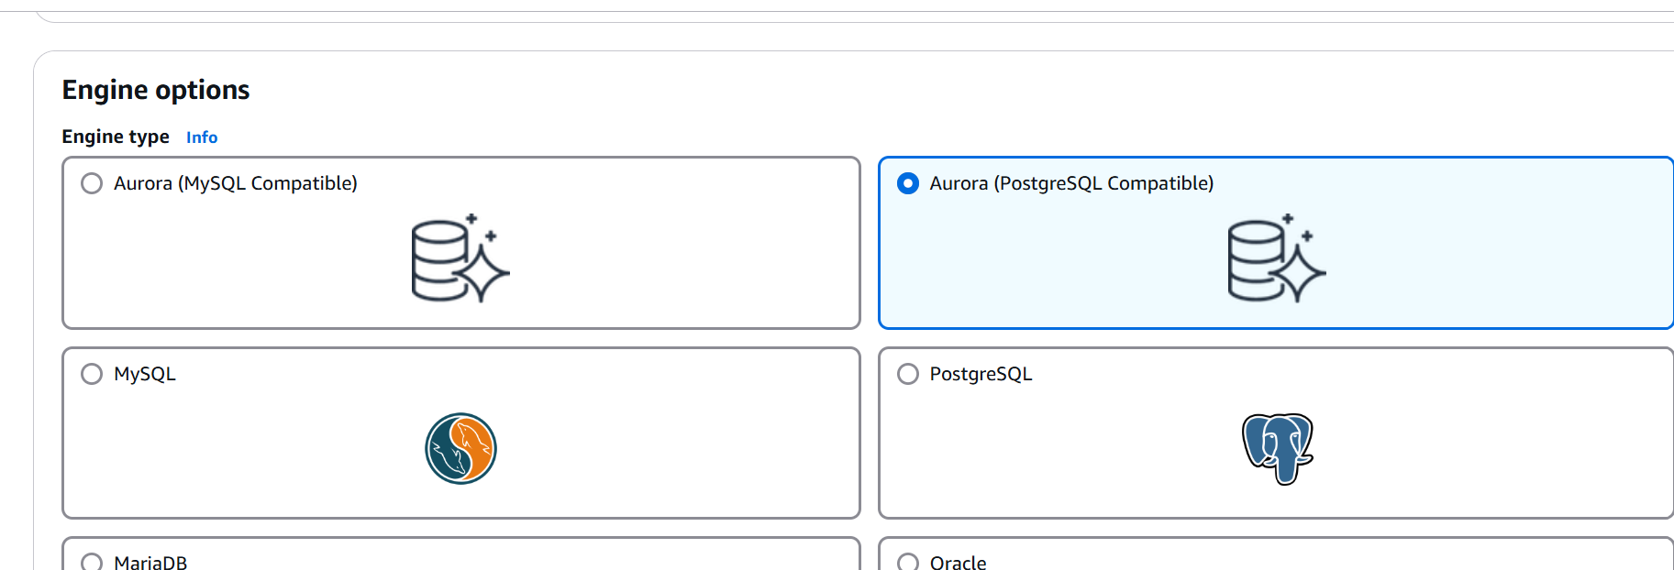

Select the template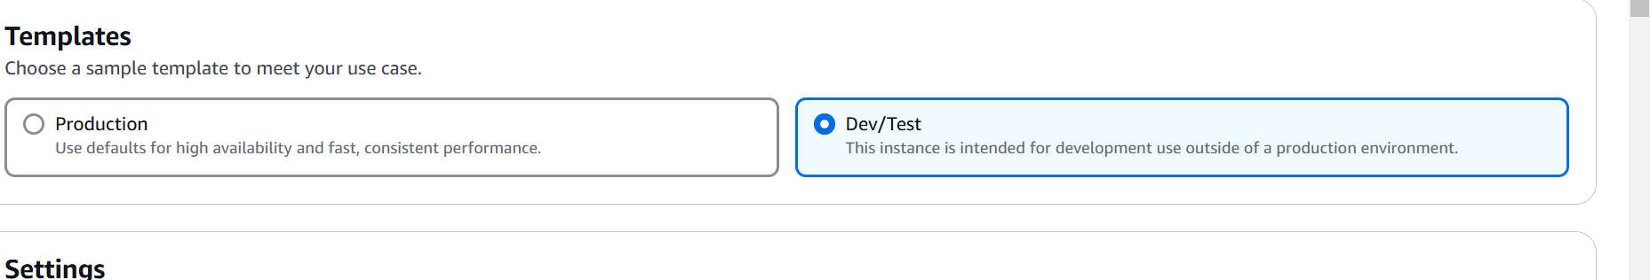

**Select an Availability and durability**

As of now we are using the free tier RDS so here we’re not able to select the Deployment options but there you can choose as per your requirement for other Environments (Prod/Dev/Test)

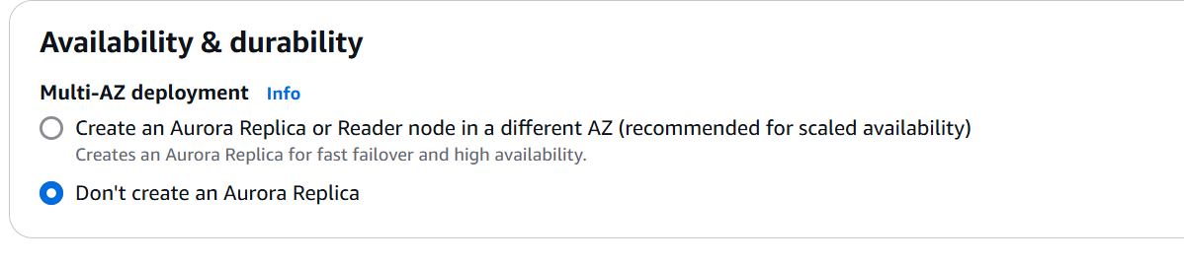

Rest parameters you can keep it default.

As per your requirement you can map

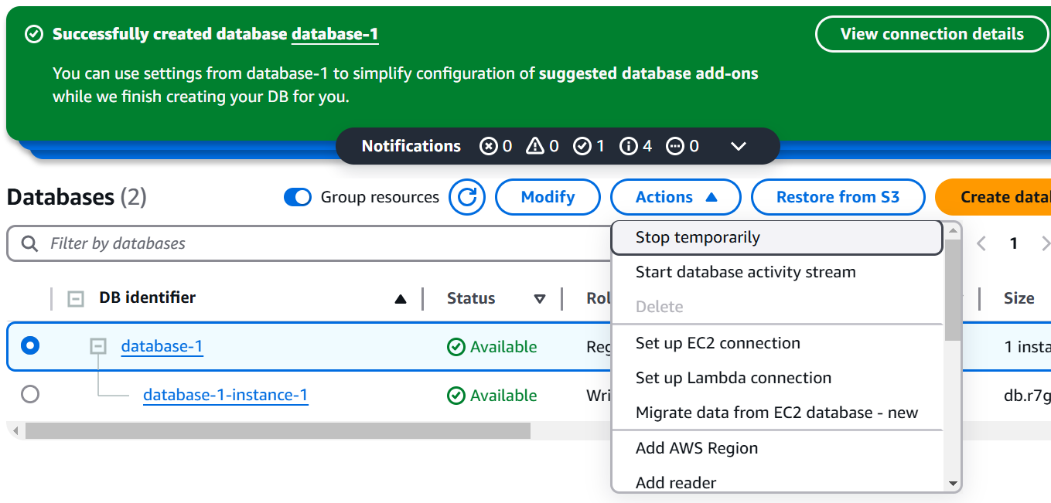

Note: Delete DB instance

